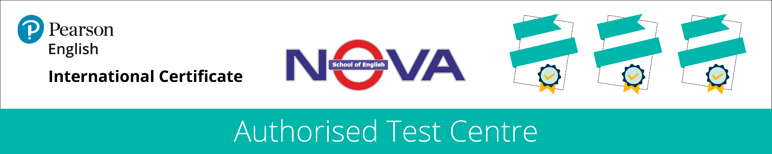

Certificate of Completion
This is to certify that

Ms. Ekaterina Bashkatova

successfully completed
a 9-hour course
“An introduction to teaching ESL”
at Nova School of English
between August 15, 2022 and August 19, 2022

Margarita Churkina
Academic Director

Date of issue: August 19, 2022

